ULTRA-LUXURY OCEAN CRUISING
The Essential Guide to the World’s Most Refined Small-Ship Voyages

Bruce M. Schutte, CTA
Luxury Cruise & Wine Travel Specialist
Founder, Capon River Cruise Company

Space. Service. Seamless Travel.
A different way to experience the world at sea.

© 2026 Bruce M. Schutte
All rights reserved.

For my mother —
thank you for your love, your guidance, and the gift of curiosity.
About the Author
Bruce M. Schutte, CTA
Founder – Capon River Cruise Company
For more than three decades, Bruce Schutte has worked in the world of fine wine, helping restaurants, retailers, and collectors discover exceptional producers from around the world. Through that experience, he developed a deep appreciation not only for great wines, but for the regions, cultures, and people behind them.
Over time, that passion naturally expanded into travel. He started his venture into travel working closely with the Virginia Wine Marketing Office where he was responsible for guiding VIPs, media, and wine professionals to the Virginia vineyards.
Many of the world’s most celebrated wine regions are connected by rivers and coastlines — Bordeaux, Burgundy, the Rhône Valley, the Douro Valley, and beyond. Visiting these places firsthand revealed something important: the most meaningful travel experiences are rarely rushed. They unfold slowly, allowing time to understand the landscape, the culture, and the stories behind each destination.
That philosophy is what led Bruce to establish Capon River Cruise Company, a boutique travel advisory focused on river cruising and Ultra-Luxury ocean voyages.
His goal is simple: help travelers experience the world’s most remarkable destinations with ease, comfort, and thoughtful guidance.
Bruce is a Certified Travel Associate (CTA) and continues to draw on his background in wine to design travel experiences that connect culture, cuisine, and place.
This guide was written to help travelers understand the evolving world of Ultra-Luxury ocean cruising — and to make choosing the right journey easier.

Who Is This Guide For?
This guide was written for travelers who believe the journey should feel as rewarding as the destination itself.
You may find yourself drawn to Ultra-Luxury cruising if you value space, comfort, and thoughtful service over crowds and constant activity. Many travelers who discover this category have already experienced traditional cruises or resort vacations and are now looking for something more refined.
Rather than seeking more entertainment or bigger ships, they are seeking a better travel experience.
This guide is especially helpful for travelers who:
• Prefer smaller ships and quieter environments over large resort-style cruise ships
• Appreciate fine dining, wine, and culinary culture as part of travel
• Value personalized service and attention to detail
• Enjoy immersive destinations rather than rushed itineraries
• Prefer elegant, well-designed accommodations with space to relax
• Want a travel experience where many details are included and handled seamlessly
Ultra-Luxury cruising is particularly appealing to travelers who enjoy the atmosphere of boutique hotels, private yachts, or small luxury resorts. The environment is relaxed and sophisticated, designed for guests who appreciate quality, comfort, and meaningful experiences.
At the same time, this category is not about extravagance or excess. It is about refinement — travel that feels calm, intentional, and well considered.
If you enjoy discovering new cultures, great food, beautiful landscapes, and thoughtful hospitality, Ultra-Luxury cruising may offer one of the most rewarding ways to explore the world.
The purpose of this guide is simple:
to help you understand the differences between the leading Ultra-Luxury cruise lines, so you can choose the journey that best aligns with your own style of travel.
Because the best voyage is not simply the most expensive one.
It is the one that feels like it was designed for you.
Table of Contents
About the Author
____________________________________________________________________________________
Introduction
Why Ultra-Luxury Ocean Cruising Is Redefining Travel

Understanding the Ultra-Luxury Cruise Category
What Defines Ultra-Luxury Cruising?
Who Ultra-Luxury Cruising Is Not For
Why Luxury Cruising Is Moving Toward Smaller Ships
The Difference Between Premium and Ultra-Luxury Cruising

The Foundations of Ultra-Luxury Cruising
1. Smaller Ships
Space, Access, and a Different Rhythm of Travel
The Solo Traveler in Ultra-Luxury Cruising
2. Elevated Culinary Programs
Dining as a Destination
Michelin-Level Culinary Partnerships at Sea
3. Everything Included
The Luxury of Simplicity
4. Service Standards & Personalization
The Difference You Feel, Not Just See
5. Space Per Guest & Design Philosophy
Luxury Measured in Room to Breathe

Ultra-Luxury Cruise Line Profiles
Regent Seven Seas Cruises
Comprehensive Inclusion & Classical Elegance at Sea
Crystal Cruises
Classic Refinement & Cultural Enrichment at Sea
Seabourn
Yacht-Style Intimacy & Understated Luxury
Explora Journeys
Modern European Luxury Reimagined at Sea
Scenic Luxury Cruises & Tours
Ultra-Luxury Meets Expedition Innovation
The Ritz-Carlton Yacht Collection
Hotel Heritage Translated to Sea

Choosing the Right Experience
How to Choose the Right Ultra-Luxury Cruise
Matching the Experience to Your Travel Style

Final Thoughts
Closing Reflections
Luxury, Defined by Ease

Begin the Conversation
Designing Your Ultra-Luxury Journey

Introduction
Why Ultra-Luxury Ocean Cruising Is Redefining Travel
For decades, ocean cruising was defined by size — larger ships, more passengers, more entertainment, more spectacle.
But travel preferences are shifting.
Today’s experienced traveler is not looking for more.
They are looking for better.
More space.
More privacy.
More thoughtful service.
More meaningful experiences.
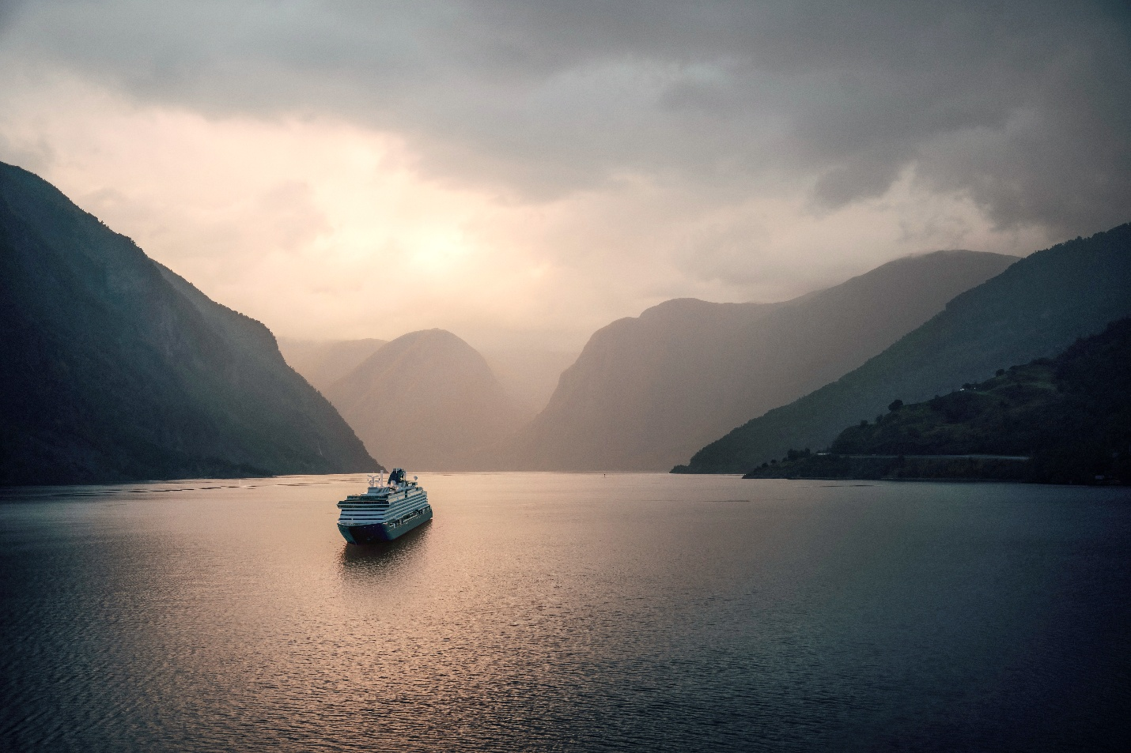
Ultra-Luxury ocean cruising has emerged not as a trend, but as a response to that shift.
For clarity, this guide focuses specifically on the Ultra-Luxury ocean cruise category — distinct from both mainstream cruise lines and river cruising. While river voyages offer their own refined appeal along inland waterways, Ultra-Luxury ocean cruising combines global reach with small-ship intimacy, expansive suites, elevated culinary programs, and highly personalized service.
It is not about excess.
It is about refinement.
These ships are significantly smaller than mainstream ocean vessels, often carrying only 200 to 750 guests. Higher crew-to-guest ratios allow service to feel personal rather than procedural. Dining becomes an extension of the destination. Excursions feel curated rather than crowded.
And perhaps most importantly, the experience becomes seamless.
In the Ultra-Luxury category, many traditional friction points of travel disappear:
No standing in long embarkation lines.
No surprise onboard charges.
No competing for dining reservations.
No feeling like one guest among thousands.
Instead, the journey feels considered.
Space per guest increases.
Balcony suites become standard.
Fine wines and premium spirits are included.
Specialty dining is not an upgrade — it is simply part of the experience.
The rhythm of travel changes.
Mornings begin without rush.
Shore experiences feel immersive rather than transactional.
Evenings unfold at an unhurried pace.
Ultra-Luxury ocean cruising is particularly appealing to travelers who value:
• Culinary excellence
• Cultural immersion
• Design and comfort
• Personalized service
• Effortless logistics
It is not designed for high-energy nightlife, water parks, or budget-first decision making. It is designed for travelers who appreciate quiet confidence in travel — where details are anticipated, inclusions are generous, and space allows for reflection.
The cruise lines featured in this guide represent leading expressions of this category. Each has a distinct personality, philosophy, and ideal traveler.
This book is designed to help you understand those differences clearly.
Because in Ultra-Luxury travel, the goal is not to choose the most expensive option.
It is to choose the right one.

Bruce M. Schutte, CTA
Luxury Cruise & Wine Travel Specialist
Founder, Capon River Cruise Company
What Defines Ultra-Luxury Cruising?
Ultra-Luxury cruise lines distinguish themselves through several defining characteristics:
• Ships typically carry fewer than 750 guests
• Suites with private balconies as the standard accommodation
• High crew-to-guest ratios approaching 1:1
• Culinary programs comparable to fine restaurants ashore
• Generous inclusion of beverages, dining, gratuities, and often excursions
While each brand approaches the category differently, these shared characteristics create a distinctly refined travel experience.
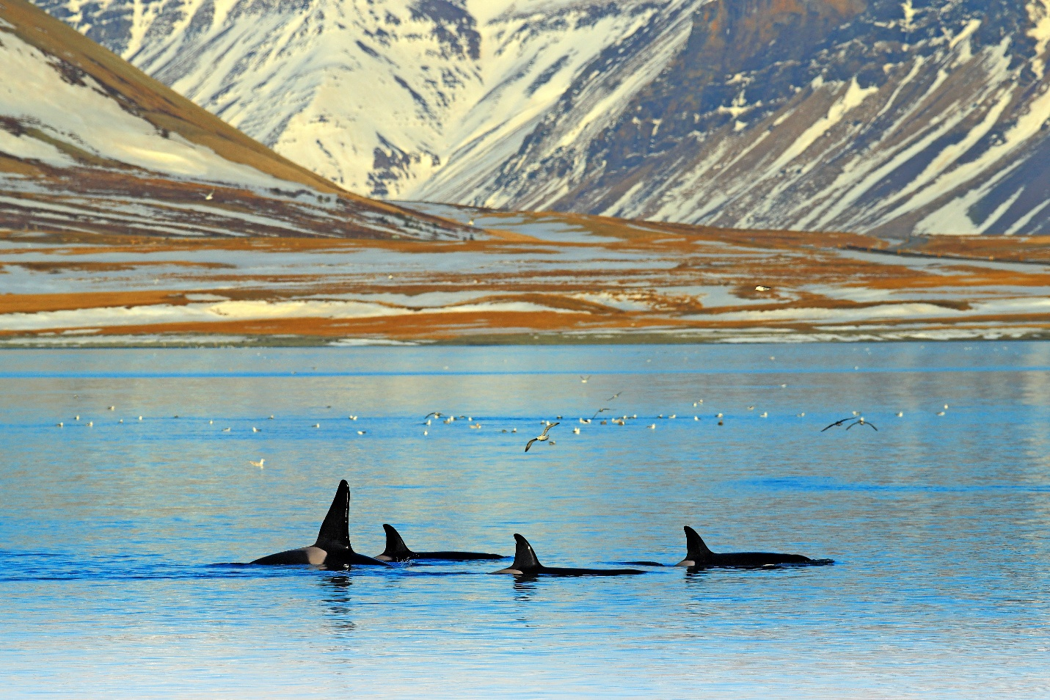

Who Ultra-Luxury Cruising Is Not For
Ultra-Luxury ocean cruising delivers an exceptional travel experience — but it is not designed for every traveler.
Understanding this distinction helps ensure the journey aligns with your expectations.
Travelers seeking large-scale entertainment and constant activity may find the Ultra-Luxury environment too relaxed. These ships prioritize space, service, and thoughtful design rather than water parks, production shows, or high-energy nightlife.
Likewise, guests who prefer budget-first travel decisions may not find the value proposition immediately compelling. Ultra-Luxury fares reflect smaller ships, higher staffing levels, spacious suites, and generous inclusions.
The category is built around refinement rather than volume.
Ultra-Luxury cruising may also feel less appealing to travelers who enjoy the bustling atmosphere of large ships with thousands of passengers. Social environments here are quieter and more intimate.
Evenings tend to revolve around conversation, fine dining, and elegant lounges rather than crowded venues.
Families with young children may also find the environment less aligned with their needs. While children are welcome on many sailings, the onboard experience is generally oriented toward adult travelers seeking relaxation, cultural immersion, and elevated service.
In many ways, Ultra-Luxury cruising appeals most strongly to travelers who value:
• Space over spectacle
• Service over scale
• Culinary quality over quantity
• Immersion over entertainment
For those travelers, the experience can feel transformative.
For others, a different style of cruising may simply be a better fit — and that clarity is part of choosing well.

Why Luxury Cruising is Moving Toward Smaller Ships
For many years, the cruise industry was defined by scale.
Ships grew larger. Passenger counts increased. Entertainment options expanded. The focus was on creating floating destinations capable of hosting thousands of guests at once.
For some travelers, that model remains appealing. Large ships offer energy, variety, and an abundance of activity.
But among experienced travelers — particularly those who have cruised before — preferences are shifting.
Increasingly, travelers who value comfort, culture, and personal space are gravitating toward smaller ships.
The reasons are both practical and experiential.

A Desire for Space
One of the most immediate differences between large ships and Ultra-Luxury vessels is the feeling of space.
When passenger numbers drop from several thousand to just a few hundred, everything changes.
Restaurants feel relaxed rather than crowded.
Lounges remain open and welcoming.
Pool decks offer room to linger.
Even simple moments — finding a quiet place to read, enjoying an unhurried dinner, watching the sea from an open deck — feel different when space is abundant.
For travelers accustomed to boutique hotels and refined environments, this shift can be transformative.
Access to Smaller, More Authentic Destinations
Size also affects where a ship can go.
Large vessels are often limited to major cruise ports designed to accommodate thousands of passengers at once.
Smaller ships have greater flexibility.
They can dock in smaller harbors, visit lesser-known islands, and arrive directly in the historic centers of coastal towns.
Instead of tendering ashore with long lines and large crowds, guests often step directly from the ship into the destination itself.
This access allows itineraries to feel more immersive and less commercialized.
A Quieter Social Environment
Another appeal of smaller ships is atmosphere.
On large vessels, the energy can feel similar to that of a resort — lively, active, and sometimes crowded.
Ultra-Luxury ships create a different social rhythm.
With fewer guests onboard, interactions feel natural rather than overwhelming. Conversations develop more easily. Public spaces maintain a calm, elegant tone.
Evenings often revolve around dining, conversation, and music rather than large-scale entertainment.
For travelers who value thoughtful conversation and a relaxed environment, this atmosphere can feel far more appealing.

The Shift Toward Quality Over Quantity
Ultimately, the movement toward smaller ships reflects a broader shift in travel itself.
Experienced travelers often reach a point where the goal is no longer to see as much as possible.
Instead, the focus becomes depth.
Fewer destinations.
More time in each place.
More meaningful experiences.
Smaller ships align naturally with that philosophy.
They emphasize comfort over spectacle, immersion over scale, and thoughtful design over constant activity.
For many travelers, the appeal is simple.
The journey becomes quieter.
More personal.
More intentional.
And in that environment, the destinations themselves can take center stage.
The Difference Between Premium and Ultra-Luxury Cruising
Cruise lines are often grouped into broad categories — mainstream, premium, luxury, and Ultra-Luxury. While these distinctions are sometimes blurred in marketing materials, the difference between premium and Ultra-Luxury cruising is significant once experienced firsthand.
Both categories offer comfortable ships, quality dining, and memorable itineraries. However, the philosophy behind each level of travel is quite different.
Premium cruise lines are designed to provide elevated experiences for many guests. Ships may carry several thousand passengers and offer a wide variety of restaurants, entertainment venues, and onboard activities.
Ultra-Luxury cruising approaches travel from a different perspective.
Rather than focusing on scale and variety, the emphasis shifts toward space, personalization, and refinement.

Ship Size and Guest Experience
Premium cruise ships often carry between 2,000 and 4,000 passengers.
Ultra-Luxury vessels typically accommodate only 200 to 750 guests.
This difference in scale transforms the onboard atmosphere. Public spaces feel more relaxed. Dining venues operate at a slower pace. Guests rarely encounter lines or crowded areas.
The experience feels closer to a private club than a large resort.
Space and Accommodation
Premium cruise ships offer a mix of cabin types, with balcony rooms and suites representing upgrades.
In Ultra-Luxury cruising, suites with private verandas are often the standard rather than the exception.
Accommodations are designed as living spaces rather than simply places to sleep, with larger bathrooms, walk-in closets, and seating areas intended for relaxation.
For longer voyages, this additional space significantly enhances comfort.
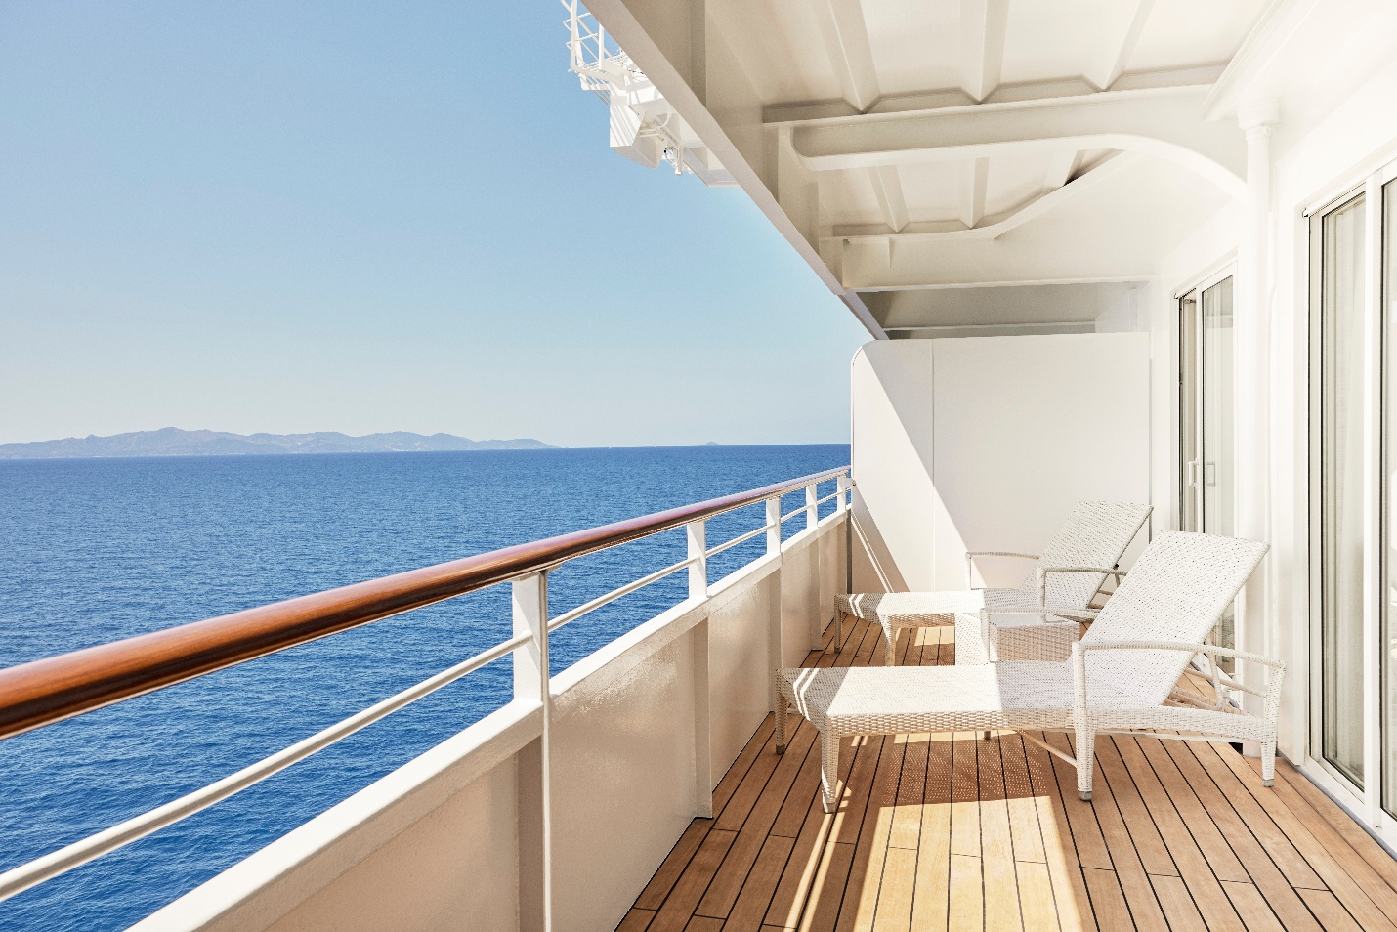
Inclusion and Simplicity
Another major distinction lies in how costs are structured.
Premium cruises often operate with a base fare supplemented by optional add-ons such as beverage packages, specialty dining, shore excursions, Wi-Fi, and gratuities.
Ultra-Luxury lines remove much of that complexity.
Inclusions frequently cover fine wines and spirits, specialty restaurants, Wi-Fi, gratuities, and shore excursions. Some brands also include airfare and transfers.
This structure changes the emotional tone of the voyage.
Instead of managing a series of decisions and charges, guests simply enjoy the journey.
Service Standards
Perhaps the most meaningful difference appears in service.
Premium ships may have one crew member for every two or three guests.
Ultra-Luxury vessels often approach a nearly 1:1 crew-to-guest ratio.
This allows staff to provide highly attentive, personalized service. Preferences are remembered, requests are handled quickly, and the overall environment feels calm and well-coordinated.
A Different Philosophy of Travel
Ultimately, premium cruising emphasizes variety and entertainment.
Ultra-Luxury cruising emphasizes refinement, space, and effortless travel.
Both can deliver wonderful vacations. The choice depends on what a traveler values most.
For those who appreciate quiet elegance, thoughtful service, and immersive destination experiences, the category offers a distinct and compelling alternative.

Why Ultra-Luxury Cruising Is Redefining Travel
1. Smaller Ships
Space, Access, and a Different Rhythm of Travel
One of the defining characteristics of Ultra-Luxury cruising is scale.
While mainstream cruise ships may carry 3,000 to 6,000 guests, Ultra-Luxury vessels often accommodate just 200 to 750 passengers — sometimes even fewer in yacht-style formats.
That difference fundamentally changes the experience.
While these vessels are significantly smaller than mainstream ocean cruise ships, they are larger than river vessels and designed for open-sea sailing.

Fewer Guests
With fewer passengers onboard, the atmosphere shifts immediately.
There are no long embarkation lines.
No crowded pool decks.
No competition for dining reservations.
Public spaces feel open. Lounges feel relaxed. Elevators are rarely full.
The experience becomes quieter and more intentional — closer to a private club at sea than a floating resort.
For many travelers, this sense of calm is the first thing they notice.

The Solo Traveler in Ultra-Luxury Cruising
Ultra-Luxury ocean cruising is often associated with couples — but it is equally well suited to the independent traveler.
On larger mainstream ships, sailing solo can sometimes feel isolated. The scale is vast, and the environment can be designed around group dynamics. In the Ultra-Luxury category, smaller ships create a different experience.
With fewer guests onboard, interaction feels natural rather than overwhelming. Social spaces are intimate. Dining venues are elegant but relaxing. It is easy to engage in conversation — and equally easy to enjoy quiet solitude.
Many Ultra-Luxury brands have responded to the growth of sophisticated solo travelers by:
• Offering reduced single supplements on select sailings
• Designing spacious suite accommodations that feel comfortable for one
• Creating dining environments where solo guests feel entirely at ease
• Maintaining service standards that are attentive without being intrusive
For independent travelers who value privacy, cultural immersion, and thoughtful service, Ultra-Luxury cruising offers a compelling balance.
You may spend the afternoon exploring a destination with a small group — and return to a suite that feels entirely your own.
Luxury at this level is not about companionship by default.
It is about choice.
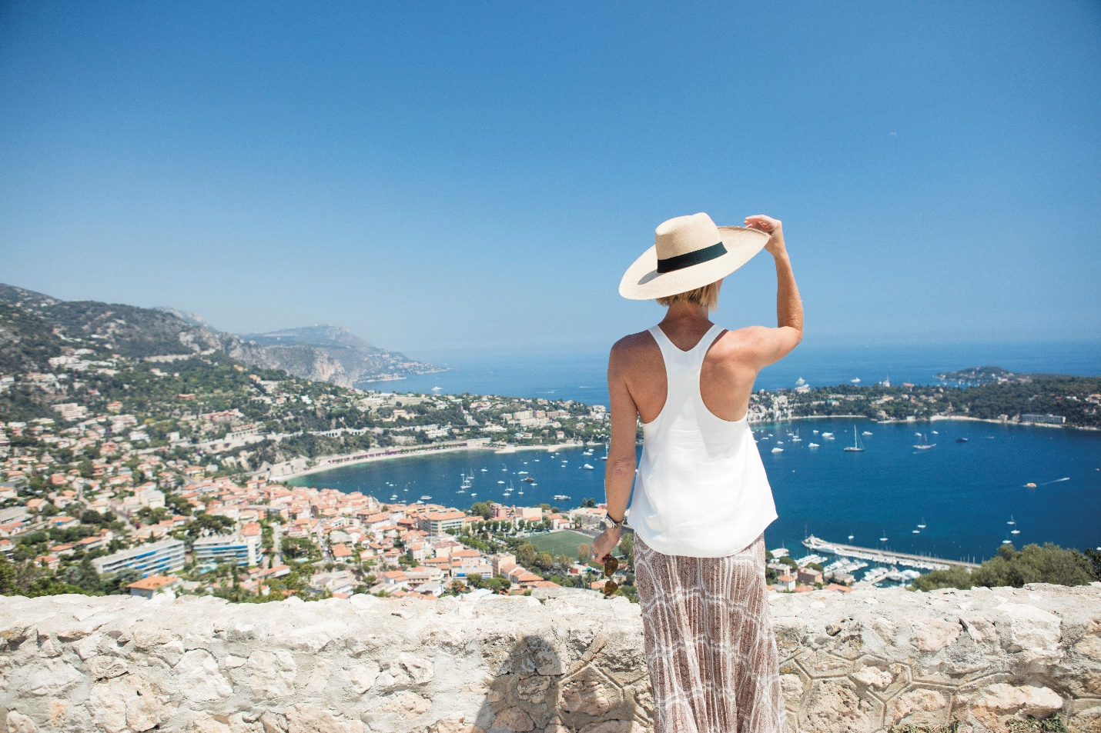
____________________________________________________________________________________

Higher Crew-to-Guest Ratio
Ultra-Luxury lines invest heavily in staffing.
Crew-to-guest ratios are often close to 1:1 — meaning nearly one crew member for every guest onboard. That translates into service that feels intuitive rather than transactional.
Your preferences are remembered.
Your name is known.
Details are handled without being requested.
Whether it is a sommelier recalling your favorite varietal or a suite attendant adjusting service times to your schedule, the difference lies in attentiveness.
Service in this category is not about formality.
It is about anticipation.

Less Congestion, More Access
Smaller ships do more than create space onboard — they open access ashore.
Because of their size, Ultra-Luxury vessels can dock in smaller ports and marinas that larger ships simply cannot reach.

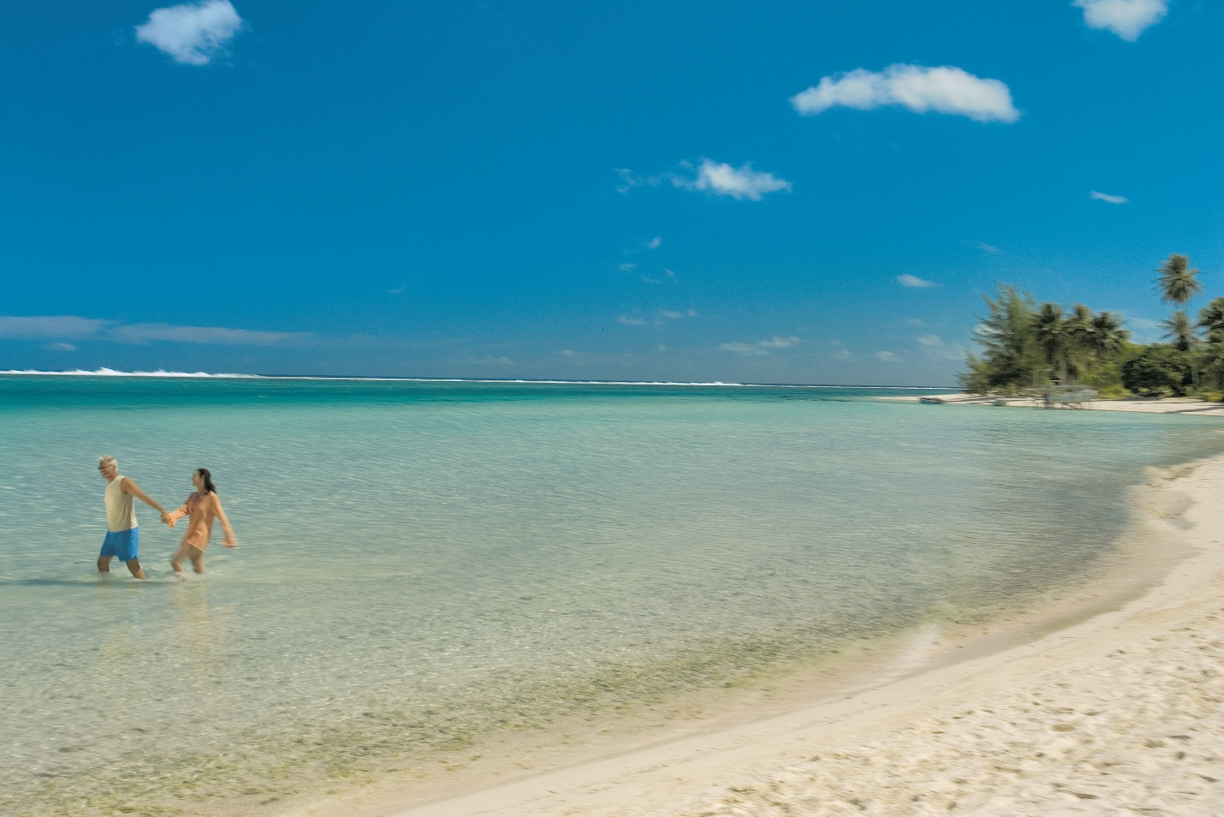
Instead of anchoring offshore and tendering thousands of passengers, these ships often arrive directly at the heart of a destination.
You step off and begin exploring.
In places like the Mediterranean, Norwegian fjords, or smaller Caribbean islands, this can mean:
• Less time in transit
• Fewer crowds
• More authentic local interaction
The ship becomes a discreet gateway, not the main attraction.

A Different Travel Tempo
Ultimately, smaller ships create a different rhythm.
There is less urgency.
Less noise.
Less spectacle.
What remains is space — physical space and mental space.
For travelers who value refinement, conversation, and immersion over constant stimulation, that difference is transformative.
Ultra-Luxury cruising begins with scale.
And scale shapes everything that follows.

2. Elevated Culinary Programs
Dining as a Destination
In Ultra-Luxury cruising, dining is not a convenience.
It is a cornerstone of the experience.
While mainstream cruise lines often focus on volume and variety, Ultra-Luxury ships emphasize quality, sourcing, and culinary identity. Meals are designed to reflect both global standards and regional authenticity.
The difference is immediately noticeable.

Fewer Guests, Higher Standards
With smaller passenger counts comes the ability to focus on precision.
Menus are not engineered for mass production.
Ingredients are carefully sourced.
Preparation is deliberate rather than rushed.
Specialty restaurants are not premium add-ons — they are part of the experience.
You are not choosing where to dine based on an upcharge.
You are choosing based on preference.
Whether it is contemporary French cuisine, refined Asian flavors, steakhouse classics, or destination-driven regional dishes, the culinary program feels curated rather than scaled.

Wine & Beverage Programs
In the Ultra-Luxury category, beverage programs receive equal attention.
Premium wines are included — not just by the glass but thoughtfully selected to complement menus and destinations.
Sommelier presence is standard.
Wine lists are balanced and regionally relevant.
Champagne flows without signature slips.
For travelers who appreciate wine, this distinction matters.
The experience is not simply about availability — it is about curation.
On itineraries through Bordeaux, Tuscany, or the Mediterranean, the wines reflect place. On expedition sailing, selections remain elevated despite remote logistics.
The consistency is part of the luxury.

Culinary Partnerships & Chef Influence
Several Ultra-Luxury cruise lines collaborate with renowned chefs, culinary institutes, or regional producers to elevate their onboard programs.
This might include:
• Chef-led tasting menus
• Culinary demonstrations
• Destination-focused cooking classes
• Market-to-table experiences
Dining becomes immersive rather than routine.
For many travelers, the food onboard rivals — and sometimes surpasses — restaurants ashore.

Personalization
In smaller dining venues, personalization becomes possible.
Dietary preferences are remembered.
Special requests are accommodated seamlessly.
Favorite wines reappear without asking.
The rhythm of dining slows.
There are no announcements encouraging you to hurry to the next activity.
Evenings stretch comfortably into conversation.

Why It Matters
Food is one of the most memorable components of travel.
In Ultra-Luxury cruising, it is treated accordingly.
The result is not indulgence for its own sake.
It is refinement — thoughtfully prepared meals, paired with carefully selected wines, served in spaces designed for comfort and conversation.
For travelers who see cuisine as part of cultural immersion, this distinction is significant.
Michelin-Level Culinary Partnerships at Sea
When Fine Dining Becomes a Defining Feature
In recent years, several Ultra-Luxury cruise lines have elevated their culinary programs even further by partnering with chefs who have earned Michelin stars ashore.
While the Michelin Guide does not formally award stars to restaurants at sea, the influence of Michelin-recognized chefs has become a defining element in the category.
This signals something important:
Ultra-Luxury cruising is not simply competing with other cruise lines.
It is competing with the world’s finest restaurants. As someone who has spent decades in the wine industry, I see clear parallels between Ultra-Luxury cruising and fine wine: scale, sourcing, and intention define the difference.
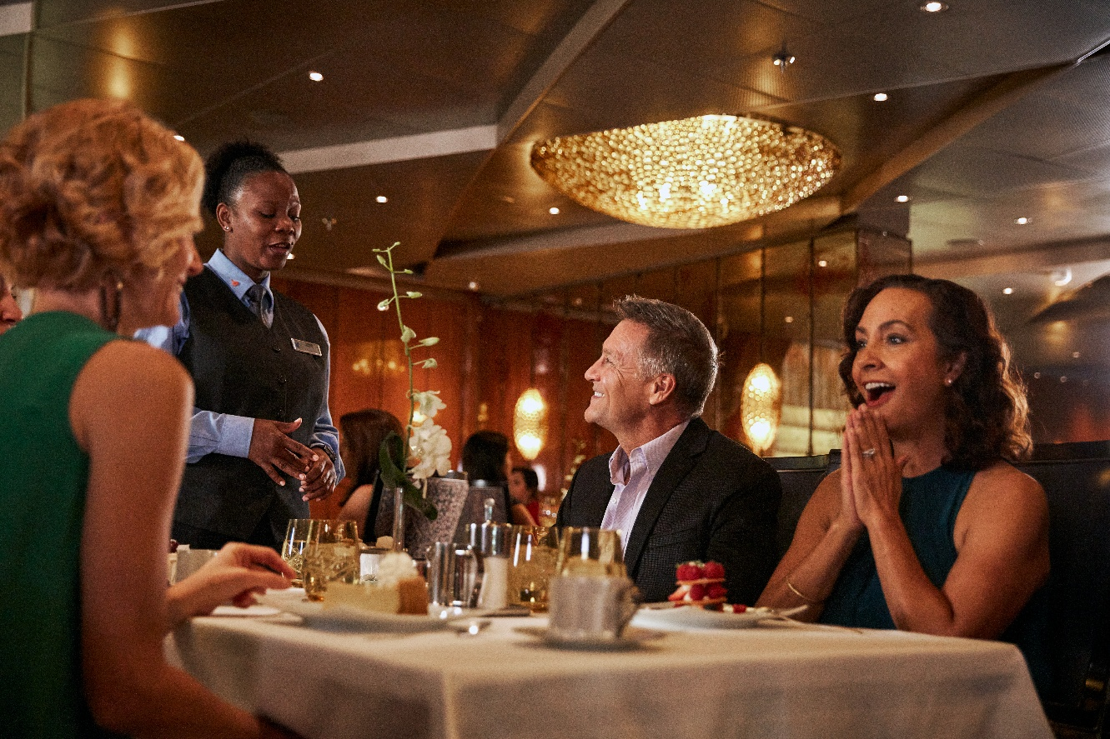

Crystal Cruises
Crystal Cruises has long emphasized fine dining as a pillar of its onboard experience.
Crystal’s culinary reputation includes refined specialty venues and partnerships with acclaimed chefs, creating tasting menus that rival high-end restaurants in major global cities.
The atmosphere remains elegant but unpretentious — allowing cuisine to take center stage.

Explora Journeys
Explora Journeys approaches dining with a distinctly European sensibility.
Its culinary program reflects collaboration with highly regarded chefs and a focus on regional sourcing, seasonal menus, and design-forward dining spaces.
The experience feels modern and intentional — less traditional formalism, more contemporary fine dining.
For travelers who value culinary innovation and aesthetic presentation, Explora stands out.

Silversea Cruises
Silversea Cruises has invested significantly in culinary development, including destination-focused menus and immersive gastronomic programming.
Its S.A.L.T. (Sea and Land Taste) program connects onboard dining directly to local culinary traditions, allowing guests to explore regional cuisine both at sea and ashore.
In select sailings, Silversea has collaborated with Michelin-recognized chefs, reinforcing its position within the refined dining category.

What This Means for the Traveler
When cruise lines attract Michelin-recognized culinary talent, it signals:
• Commitment to quality over volume
• Investment in culinary identity
• Elevated sourcing standards
• Greater attention to wine pairings and presentation
For many guests, this translates into:
Evenings that feel like reservations at world-class restaurants — without leaving the ship.

Why This Matters in Ultra-Luxury
Fine dining is not simply about prestige.
It reflects scale.
Smaller ships make it possible to execute multi-course tasting menus properly.
Higher staffing levels allow greater culinary precision.
Inclusion of premium wines allows pairing experiences without surcharge.
In this category, dining becomes part of the reason to sail — not just something that happens between excursions.
3. Everything Included
The Luxury of Simplicity
One of the most defining characteristics of Ultra-Luxury cruising is inclusion.
In many mainstream cruise experiences, the initial fare represents only part of the total cost. Specialty dining, premium beverages, gratuities, Wi-Fi, and shore excursions are often added à la carte.
Ultra-Luxury cruising approaches this differently.
The philosophy is simple:
Remove friction.
Eliminate surprise.
Allow the guest to relax.
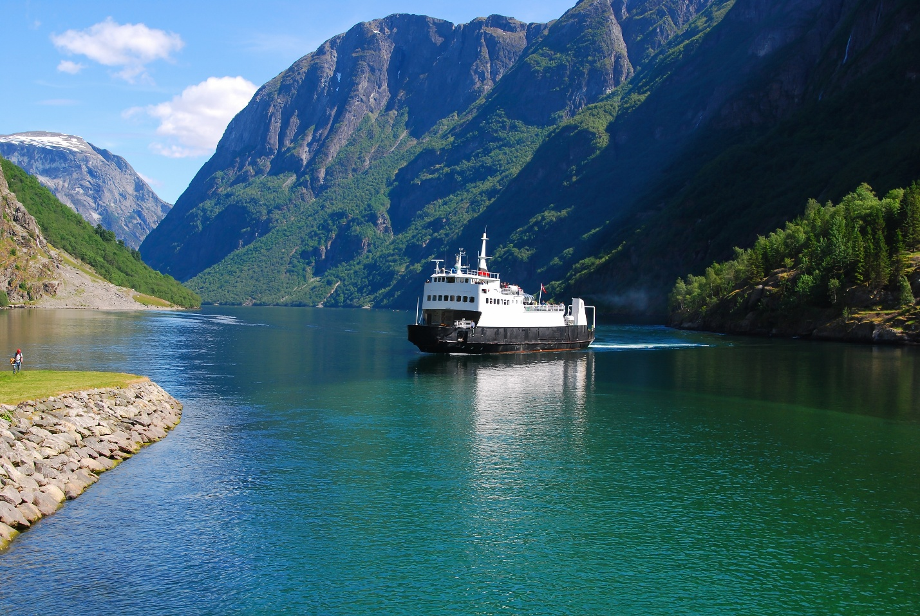

What “All-Inclusive” Really Means
In the Ultra-Luxury category, inclusion typically covers:
• Fine wines and premium spirits
• Specialty dining venues
• Gratuities
• Wi-Fi
• Shore excursions
• Transfers
• Often pre-cruise hotel packages
• In some cases, air travel
While the degree of inclusion varies slightly by brand, the goal remains the same:
Guests should not feel as though they are being upsold throughout the journey.
The experience becomes seamless.

Shore Excursions Included
One of the most meaningful distinctions is the inclusion of shore experiences.
On certain Ultra-Luxury lines, unlimited shore excursions are included in the fare. On others, a curated selection is part of the package, with optional premium experiences available.
This shift changes behavior.
When excursions are included, guests explore more freely.
They try new experiences without calculating incremental cost.
They immerse themselves rather than hesitate.
It transforms the voyage from a cruise to a series of curated cultural encounters.

The Psychological Impact
Inclusion does more than simplify budgeting.
It changes the emotional tone of the journey.
There is no signing of chits for wine at dinner.
No hesitation before ordering a second cappuccino.
No recalculating the cost of a private tour.
The mental burden disappears.
For many seasoned travelers, this is one of the greatest luxuries of all — not opulence, but ease.

Transparency vs. Sticker Price
At first glance, Ultra-Luxury fares may appear significantly higher than premium cruise options.
However, once the cost of:
• Beverage packages
• Specialty dining
• Gratuities
• Premium excursions
• Wi-Fi
• Air
• Transfers
is factored in, the difference often narrows considerably.
More importantly, the value proposition becomes clear:
In Ultra-Luxury cruising, the price you see is much closer to the price you pay.

Brand Differentiation Within Inclusion
Not all Ultra-Luxury brands structure inclusions identically.
For example:
• Regent Seven Seas Cruises is known for one of the most comprehensive inclusion models in the industry, often including unlimited shore excursions and airfare.
• Scenic Luxury Cruises & Tours similarly emphasizes a highly inclusive structure, particularly on its Scenic Eclipse vessels.
• The Ritz-Carlton Yacht Collection includes most dining and beverages but may structure certain experiences differently, reflecting its yacht-style positioning.
Understanding these nuances helps travelers select the line that best aligns with their expectations.

Why Inclusion Matters
In the Ultra-Luxury category, inclusion is not about abundance.
It is about simplicity.
When financial friction is removed, the guest experience becomes immersive rather than transactional.
You are not managing a cruise.
You are living the journey.

4. Service Standards & Personalization
The Difference You Feel, Not Just See
In Ultra-Luxury cruising, service is not simply attentive.
It is intuitive.
While premium cruise lines may offer excellent hospitality, Ultra-Luxury brands operate at a different scale — and that scale enables a different level of personalization.
The distinction is subtle, but powerful.

High Crew-to-Guest Ratios
One of the defining metrics in Ultra-Luxury cruising is the crew-to-guest ratio.
On many ships in this category, staffing approaches nearly one crew member per guest.
That staffing level changes everything.
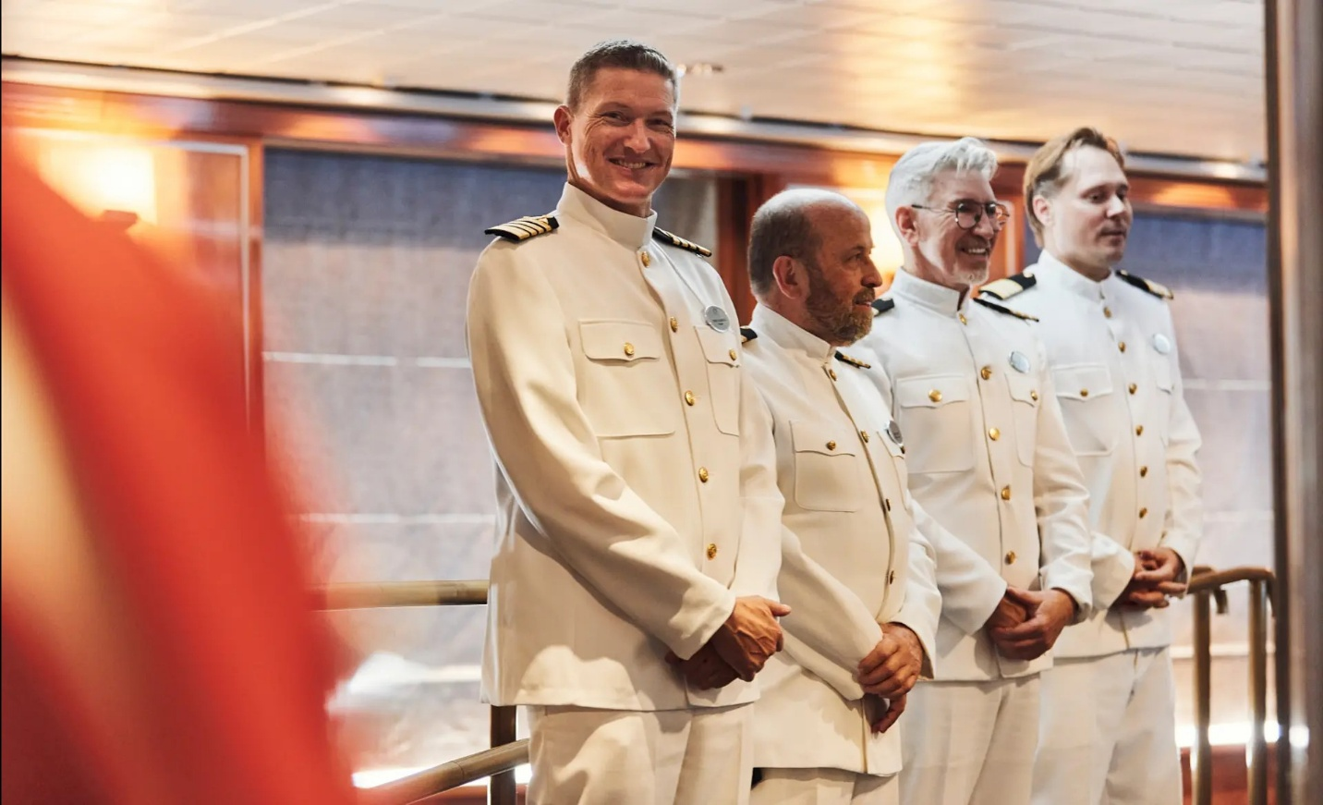
Requests are handled immediately.
Preferences are remembered.
Details are anticipated rather than addressed after the fact.
There is no sense of hurry.
Instead, the environment feels calm and controlled.

Recognition & Continuity
On smaller ships, familiarity develops quickly.
Guests are greeted by name.
Dining staff recall favorite wines.
Suite attendants adapt to preferred schedules.
This continuity creates comfort.
You are not one of thousands rotating through a system.
You are known, usually by your first name.

Butler Service & Suite-Level Attention
Several Ultra-Luxury lines include butler service in many or all suite categories.
This may include:
• In-suite dining coordination
• Packing and unpacking assistance
• Laundry services
• Priority arrangements ashore
• Personalized beverage setup
While some guests rarely use these services, others find them transformative — particularly on longer voyages.
The presence of butler service signals a philosophy of individual care.

Training & Culture
Ultra-Luxury brands invest significantly in staff training.
Service tends to be:
• Professional without being rigid
• Friendly without being intrusive
• Consistent across departments
The best crews balance discretion with warmth.
For experienced travelers, this consistency is often the clearest indicator of category distinction.

Emotional Luxury
True luxury is rarely loud.
It is the absence of inconvenience.
It is the quiet confidence that someone has already thought of what you might need.
Whether that is a preferred table, a specific pillow type, or a seamlessly arranged private transfer, personalization elevates the experience beyond amenities.
It becomes relational.

Why Service Defines the Category
Ships can be elegant.
Suites can be spacious.
Cuisine can be refined.
But it is service that determines whether a voyage feels premium — or truly exceptional.
In Ultra-Luxury ocean cruising, the human element is not an enhancement to the experience. It is the experience.
While design and amenities create comfort, it is thoughtful, attentive service that creates ease. The difference is subtle at first, then unmistakable.
Preferences are remembered.
Details are anticipated.
Requests are handled quietly and efficiently.
Guests are not navigating systems or waiting in lines. Instead, they move through each day with a sense of calm continuity — a feeling that everything is unfolding exactly as it should.
Presence Without Intrusion
Service at this level is attentive without being overbearing.
Staff members seem to appear at precisely the right moment, helping without interrupting conversation or quiet reflection. A favorite table is ready without request. A preferred beverage arrives unprompted. Shore arrangements unfold seamlessly.
The interaction feels natural rather than procedural. For many travelers, this absence of friction becomes one of the most memorable aspects of the journey.
Scale Enables Personalization
Smaller ships make this level of service possible.
With fewer guests onboard and crew-to-guest ratios often approaching one-to-one, staff have the time and awareness to provide genuinely personalized care. Conversations feel unhurried. Assistance feels sincere. Hospitality feels human.
Guests are not numbers on a manifest. They are individuals whose comfort and enjoyment matter.
The Emotional Impact of Thoughtful Service
Exceptional service changes how travel feels.
It removes decision fatigue.
It reduces logistical stress.
It allows travelers to be fully present in each moment.
Instead of managing reservations, schedules, and arrangements, guests can focus on the experiences themselves — the destinations, the cuisine, the scenery, the company.
This shift from coordination to immersion is one of the defining qualities of Ultra-Luxury cruising.
Why Guests Return
Many travelers remember the destinations they visit. But they return for how the experience made them feel.
Ultra-Luxury service creates a sense of being genuinely cared for — not through grand gestures, but through consistent, thoughtful attention to detail.
It is hospitality practiced as an art form.
And for many guests, it becomes the reason they sail again.
5. Space Per Guest & Design Philosophy
Luxury Measured in Room to Breathe
One of the most overlooked distinctions in Ultra-Luxury cruising is space.
Not just suite size — but overall space per guest.
This metric, often referred to as “space ratio,” reflects the volume of public and private space available onboard relative to the number of passengers.
In Ultra-Luxury ships, this number is significantly higher than in mainstream cruising.
The result is immediate and perceptible.

Larger Suites as Standard
In many Ultra-Luxury lines, balcony suites are not an upgrade — they are the baseline.
Suite sizes frequently begin where premium cruise cabins end.
Spacious bathrooms.
Walk-in closets.
Comfortable seating areas.
Private verandas designed for lingering.
The suite is not simply a place to sleep.
It becomes a retreat.
For longer voyages, this matters greatly.

Public Spaces Without Crowding
Beyond the suite, generous space allocation changes how the ship feels.
Lounges rarely fill to capacity.
Pool decks feel relaxed rather than busy.
Restaurants maintain atmosphere rather than turnover.
You are not navigating crowds.
You are moving through well-designed environments that feel intentional and proportioned.
This quiet spaciousness is one of the most immediate differences guests notice.

Design Philosophy
Ultra-Luxury brands invest heavily in design — not for spectacle, but for comfort and flow.
The aesthetic tends toward:
• Natural light
• Neutral palettes
• Elegant materials
• Clean architectural lines
The atmosphere feels residential rather than theatrical.
Ships are designed to feel like refined boutique hotels or private yachts, rather than floating entertainment complexes.
Even the acoustics are different — quieter corridors, softer ambient sound, fewer loud announcements.
The absence of noise becomes part of the luxury.

Outdoor Space & Private Retreat
Outdoor space is equally important.
Generous deck layouts allow for:
• Uncrowded loungers
• Private cabana-style seating
• Quiet observation areas
On yacht-style vessels, marina platforms and open decks enhance the sense of intimacy and connection to the sea.
You are not simply transported between destinations.
You are surrounded by them.

Why Space Defines Experience
Luxury is not defined solely by materials or décor.
It is defined by how space makes you feel.
When there is room to breathe, room to move, and room to retreat, travel slows.
Conversations lengthen.
Moments linger.
Experiences deepen.
In Ultra-Luxury cruising, space is not incidental.
It is engineered.
And that design philosophy shapes everything that follows.
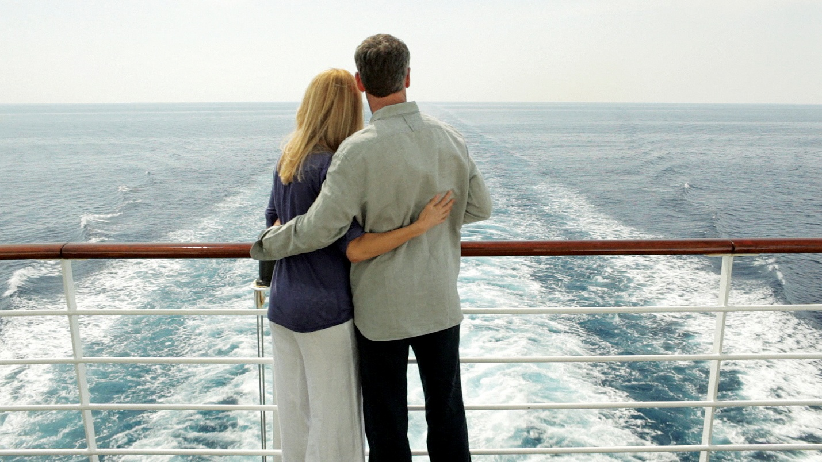
Regent Seven Seas Cruises
Comprehensive Inclusion & Classical Elegance at Sea
Regent Seven Seas Cruises
Among Ultra-Luxury cruise lines, Regent is often viewed as the standard-bearer for fully inclusive travel. Its philosophy centers on removing nearly every financial friction point so guests can experience a voyage without transactional interruptions.
Regent does not position itself around spectacle or trend. Instead, it emphasizes comfort, consistency, and completeness.

Brand Identity
Regent’s identity is rooted in traditional elegance.
Ships feature:
• All-suite accommodations
• Private balconies as standard
• Marble bathrooms and spacious layouts
• Classic, refined interior design
The atmosphere feels polished and composed — less yacht-casual, more timeless luxury hotel at sea.


What Sets Regent Apart
1. One of the Most Inclusive Models in the Industry
Regent is widely recognized for offering one of the most comprehensive inclusion packages in Ultra-Luxury cruising.
Depending on the sailing, this can include:
• Unlimited shore excursions
• Fine wines & premium spirits
• Specialty dining
• Gratuities
• Wi-Fi
• Transfers
• Often business-class air
For travelers who dislike incremental charges, this structure is compelling.
It allows guests to focus entirely on experience rather than cost tracking.

2. Spacious Accommodations
Regent’s suite sizes are consistently among the largest in the category.
Even entry-level suites provide generous square footage, separate seating areas, and balcony space that feels usable rather than symbolic.
For extended voyages, this added space significantly enhances comfort.

3. Elevated Culinary Standards
Regent’s dining program emphasizes refined, multi-course cuisine across several specialty venues.

Dining is included across all restaurants, and wine service is designed to complement menus without surcharge.
The culinary philosophy leans toward classic European technique with global influence — consistent, polished, and well-executed.

4. Service Consistency
Regent’s crew-to-guest ratios support attentive, professional service.
Butler service is included in higher suite categories, and personalization develops naturally on smaller ships.
The experience is formal enough to feel special, yet warm enough to feel relaxed.
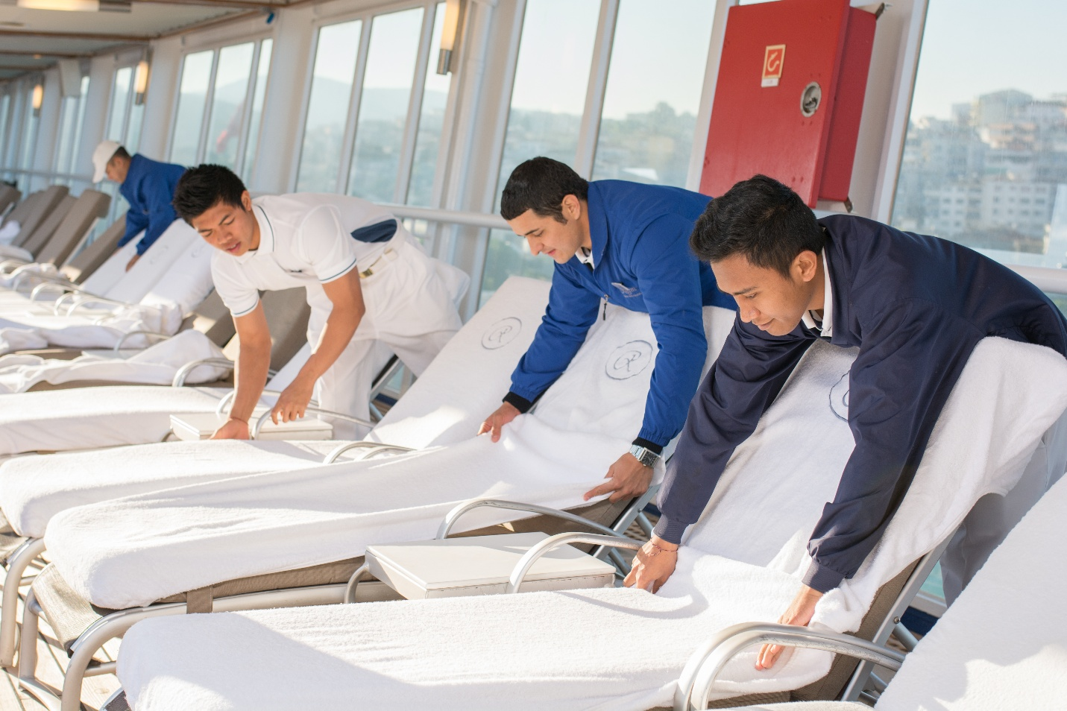

Ideal Traveler Profile
Regent tends to appeal to travelers who:
• Prefer comprehensive inclusion
• Value spacious accommodations
• Appreciate classic elegance
• Seek cultural enrichment without expedition intensity
• Want minimal onboard financial decisions
It is particularly attractive to seasoned travelers who prioritize comfort and predictability at a high standard.

When Regent May Not Be the Best Fit
Regent’s atmosphere is refined and traditional.
Travelers seeking:
• Ultra-modern design
• Yacht-style intimacy
• High-adventure expedition focus
• Nightlife-driven energy
may find other brands better aligned with their preferences.
Ultra-Luxury is not one-size-fits-all — and understanding personality alignment matters.

Price Positioning
Regent sits firmly in the upper tier of the Ultra-Luxury category.
However, once airfare, excursions, dining, beverages, and gratuities are factored in, the value proposition becomes clearer for travelers who intend to participate fully.
The fare reflects simplicity.
And simplicity, in this segment, is part of the appeal.

Crystal Cruises
Classic Refinement & Cultural Enrichment at Sea
Crystal has long been associated with timeless elegance and enrichment-focused cruising. While the brand has evolved over the years, its identity remains rooted in refined service, spacious ships, and a strong commitment to cultural programming.
Crystal appeals to travelers who value tradition, intellectual engagement, and polished execution.
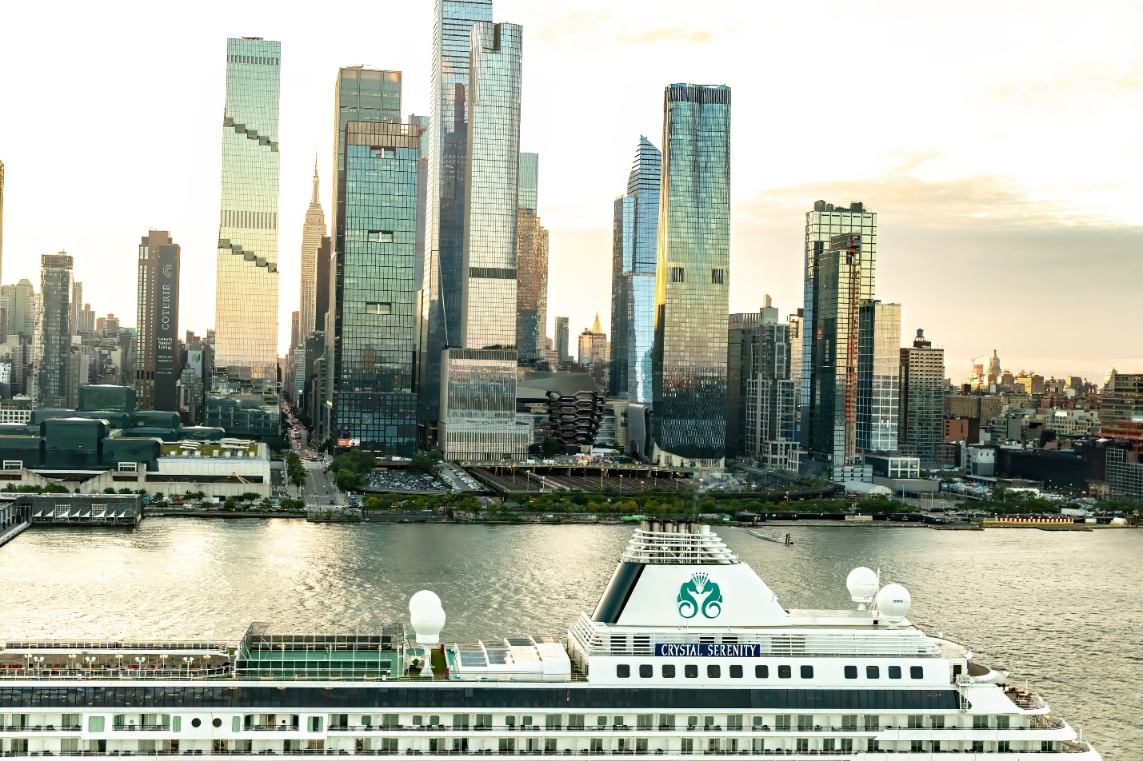

Brand Identity
Crystal’s aesthetic leans toward classic luxury.
Ships are designed with:
• Elegant public spaces
• Refined dining venues
• Spacious suites
• A formal-yet-welcoming atmosphere
The onboard experience feels composed and established — closer to a luxury hotel with maritime character than a yacht-style retreat.
There is an emphasis on tradition, but not rigidity.

What Sets Crystal Apart
1. Cultural & Enrichment Programming
Crystal has historically distinguished itself through strong enrichment offerings.
Guests may encounter:
• Guest lecturers and subject-matter experts
• Destination historians
• Cultural programming tied to itinerary
• Music and performance programming
For travelers who value intellectual stimulation alongside relaxation, this adds meaningful depth to the voyage.

2. Spacious Ships Without Excess Scale
Crystal’s ships are larger than some yacht-style Ultra-Luxury vessels, yet they remain well below mainstream cruise capacity. This balance allows for:
• More onboard amenities
• Multiple dining venues
• Larger wellness facilities
• Still manageable passenger counts
Guests benefit from variety without experiencing crowding.

3. Elevated Culinary Experience
Crystal places significant emphasis on dining quality.
Menus are thoughtfully structured, and specialty restaurants provide globally inspired cuisine in elegant settings.
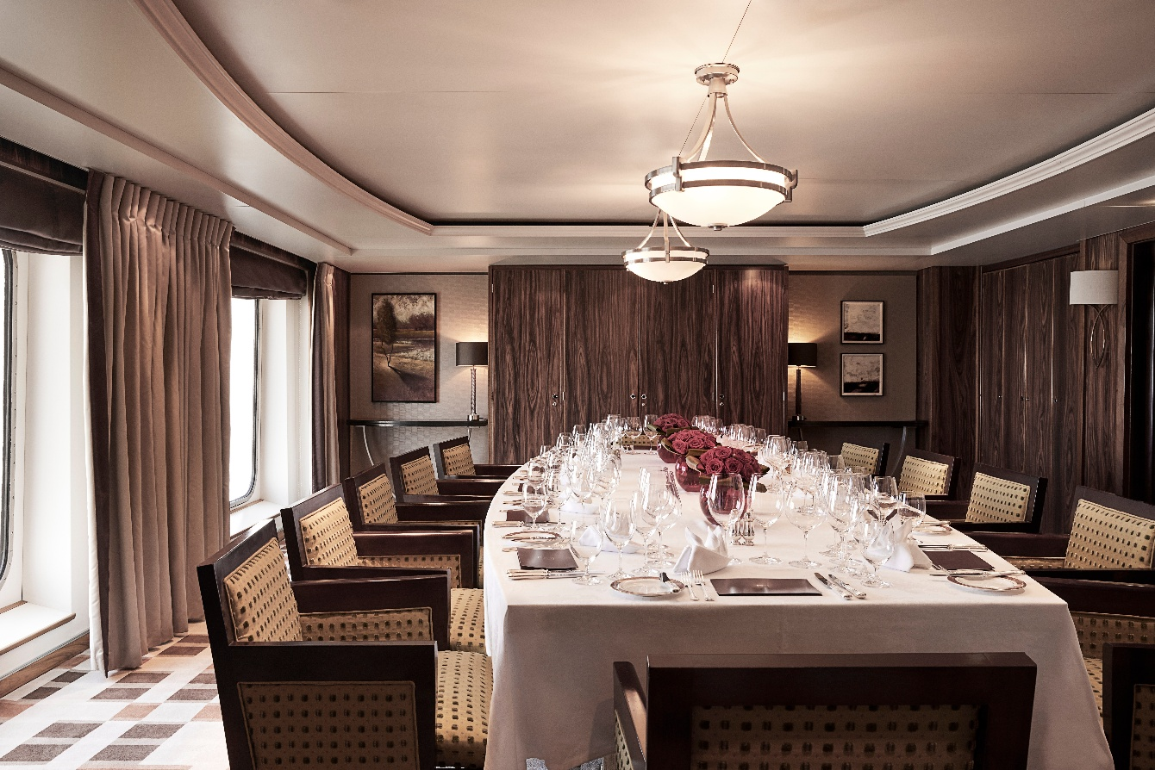
The culinary experience reflects precision and refinement rather than trend-driven experimentation.
Wine programs are well curated, and service is measured and attentive.

4. Service & Atmosphere
Crystal’s service style is polished and professional.
Crew interactions feel respectful and structured, often appealing to travelers who appreciate traditional hospitality standards.
The atmosphere onboard tends to be sophisticated rather than casual.
Evening attire may skew slightly more formal compared to some contemporary Ultra-Luxury brands.

Ideal Traveler Profile
Crystal typically appeals to travelers who:
• Appreciate classical elegance
• Value enrichment and education
• Prefer structured cultural programming
• Enjoy refined but understated luxury
• Seek a mature, composed onboard environment
Many Crystal guests are seasoned cruisers who value familiarity and consistency.

When Crystal May Not Be the Best Fit
Crystal may feel less aligned for travelers who:
• Prefer ultra-modern design aesthetics
• Seek expedition-style adventure
• Desire a highly casual yacht atmosphere
• Want a more design-forward or avant-garde experience
While still firmly within the Ultra-Luxury tier, its personality leans toward classic rather than contemporary.

Price Positioning
Crystal competes within the upper luxury and Ultra-Luxury spectrum.
Its pricing reflects:
• Elevated service standards
• Spacious accommodations
• Enrichment programming
• Culinary quality
For travelers who value structure, tradition, and cultural engagement, Crystal presents a compelling proposition within the category.

Seabourn
Yacht-Style Intimacy & Understated Luxury
Seabourn
Seabourn occupies a distinctive place within the Ultra-Luxury category.
If Regent leans toward comprehensive inclusion and classical elegance, Seabourn leans toward intimacy and relaxed refinement.
The experience often feels less like boarding a ship — and more like stepping aboard a private yacht.
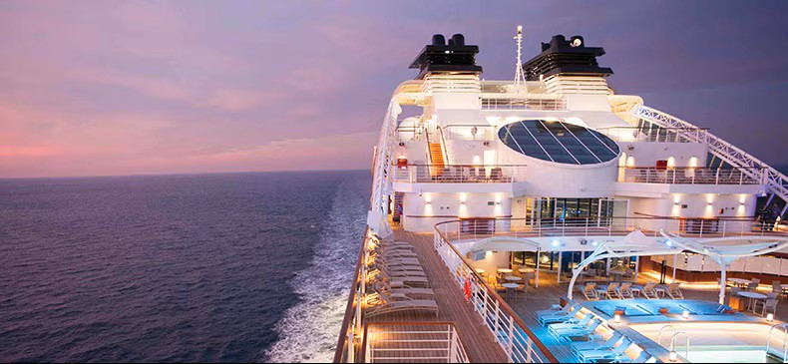

Brand Identity
Seabourn’s identity is rooted in:
• Smaller ships
• Open, airy public spaces
• Contemporary yet understated design
• A relaxed but polished atmosphere
The environment is elegant without feeling formal.
Dress codes tend to be more flexible than traditional luxury lines, and the mood is social without being crowded.
The emphasis is on personal connection — both with fellow guests and crew.

What Sets Seabourn Apart
1. Yacht-Scale Experience
Seabourn’s fleet includes some of the smallest ships in the Ultra-Luxury ocean category.
Fewer guests create:
• A more intimate onboard atmosphere
• Easier social interaction
• Direct access to smaller ports
The scale allows for a noticeable sense of privacy and exclusivity.
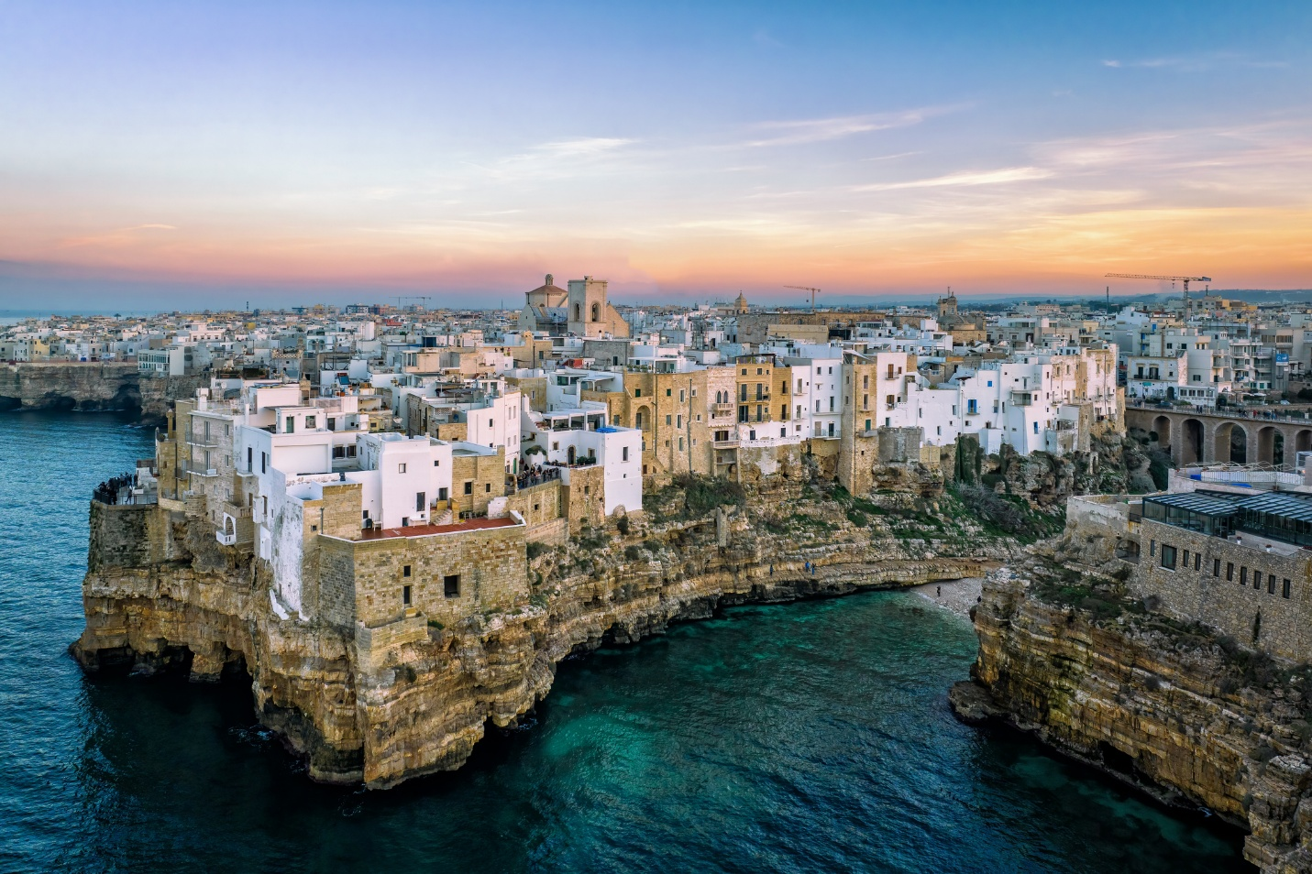

2. Service That Feels Natural
Seabourn’s service style is warm and intuitive.
Crew members often circulate freely in public areas, creating a more approachable dynamic.
The atmosphere tends to feel:
Professional, but not rigid.
Attentive, but not intrusive.
Guests often describe the experience as feeling “personal” rather than “formal.”

3. Culinary Strength
Seabourn places significant emphasis on fine dining.
Menus are refined and globally inspired, and specialty venues are included in the fare.
The brand has also collaborated with acclaimed chefs, enhancing its reputation for elevated cuisine.
Wine programs are thoughtful and well-integrated into the dining experience.
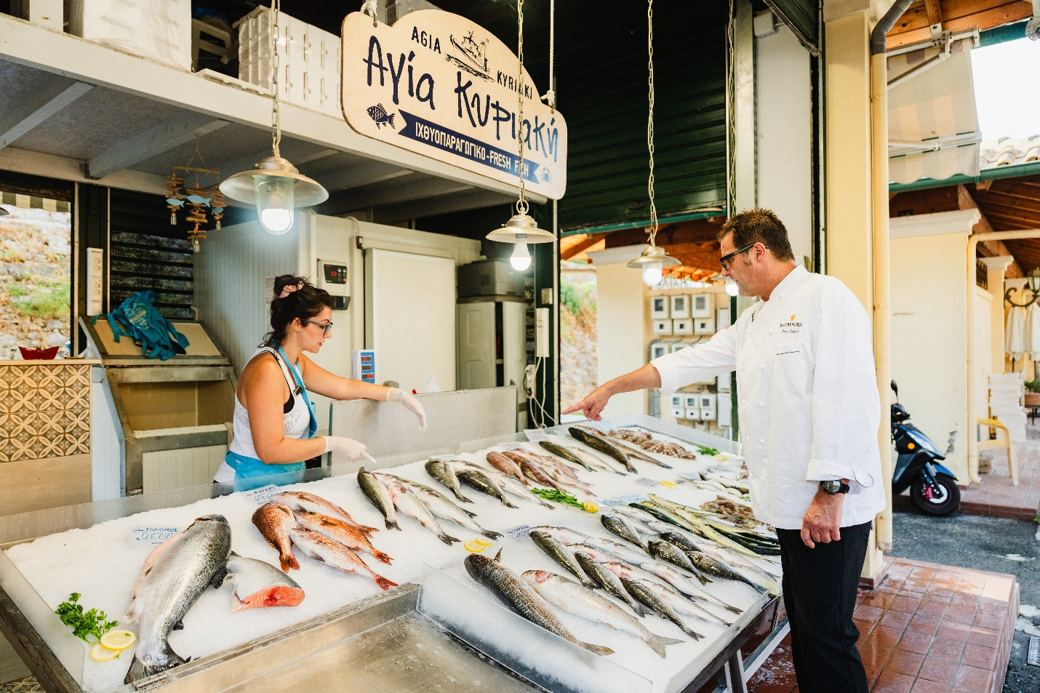

4. Expedition Capability
In addition to its classic luxury vessels, Seabourn operates purpose-built expedition ships.
These offer:
• Polar and remote itineraries
• Onboard expert teams
• Zodiac landings
• A blend of adventure and comfort
This dual capability allows Seabourn to appeal to both traditional luxury cruisers and adventure-oriented travelers seeking elevated accommodation.

Ideal Traveler Profile
Seabourn tends to attract travelers who:
• Prefer smaller ships
• Appreciate a relaxed luxury atmosphere
• Value intimacy over scale
• Enjoy culinary excellence
• May be interested in light expedition experiences
It appeals strongly to couples seeking a refined but not overly formal environment.

When Seabourn May Not Be the Best Fit
Seabourn may feel less aligned for travelers who:
• Want maximum inclusion of airfare and unlimited excursions
• Prefer highly structured enrichment programming
• Seek a very traditional, formal atmosphere
Its strength lies in experience and atmosphere rather than comprehensive inclusion models.

Price Positioning
Seabourn competes squarely in the Ultra-Luxury category.
While not always as all-encompassing in inclusions as some competitors, its value lies in:
• Intimate ship scale
• Culinary strength
• Service style
• Access to smaller ports
For travelers who want yacht-style elegance without sacrificing comfort, Seabourn offers a compelling balance.

Explora Journeys
Modern European Luxury Reimagined at Sea
Explora Journeys
Explora Journeys represents a newer expression of Ultra-Luxury cruising — one rooted in contemporary design, European hospitality, and a slower, more intentional travel rhythm.
Where some luxury lines lean into tradition, Explora embraces modernity.
The experience feels less like a formal cruise and more like a private floating retreat.
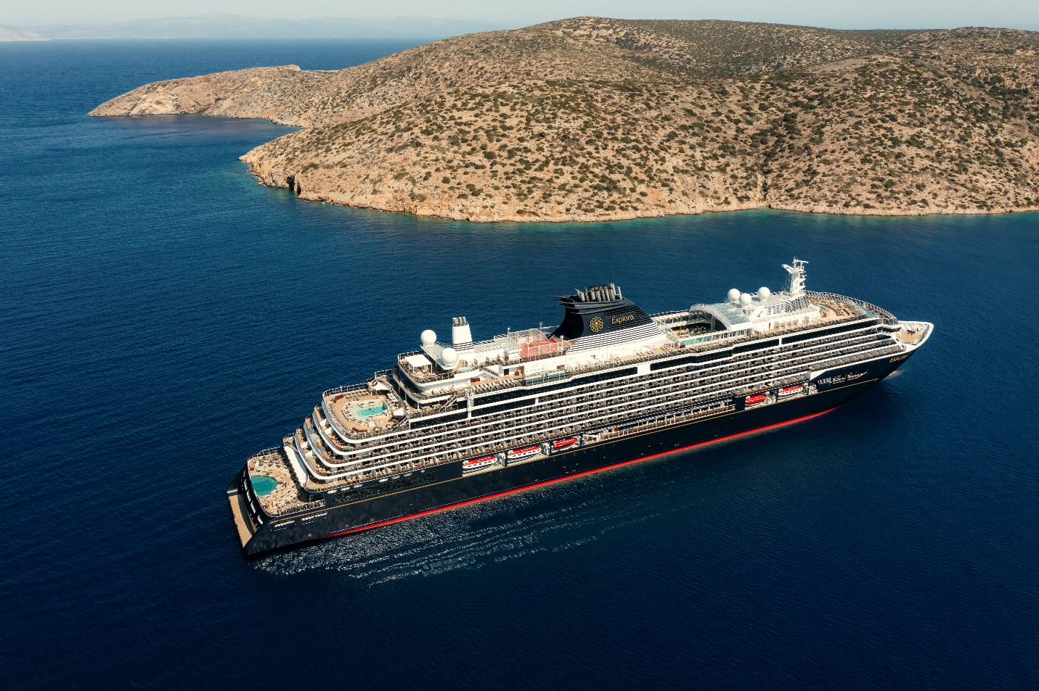

Brand Identity
Explora’s design philosophy is distinctly European and contemporary.
Ships feature:
• Ocean-front suites throughout
• Floor-to-ceiling windows
• Neutral palettes and natural textures
• Open, light-filled public spaces
The atmosphere is calm and minimalist — elegant without ornamentation.
There is an emphasis on wellness, privacy, and unhurried exploration.

What Sets Explora Apart
1. Ocean-Front Suite Standard
Explora’s accommodations are entirely suite-based, with generous verandas and spacious layouts designed to feel residential.
The suite becomes a central part of the journey — a sanctuary rather than simply a stateroom.
Design-forward details and subtle luxury touches create a refined but understated environment.

2. Slower Travel Philosophy
Explora’s itineraries often feature:
• Longer port stays
• Overnight calls
• Fewer rushed sea days
• More time for immersive experiences
The focus is not on checking destinations off a list.
It is on absorbing them.
For travelers who dislike tight port schedules, this pacing can be particularly appealing.

3. Culinary Approach
Explora emphasizes destination-inspired cuisine and modern presentation.
Dining venues feel boutique and thoughtfully designed.
Menus reflect regional sourcing, seasonal ingredients, and European culinary sensibilities.
The overall tone is refined and contemporary rather than formal or theatrical.
Wine programs are curated with attention to balance and pairing — aligning naturally with travelers who appreciate thoughtful beverage selection.

4. Wellness & Atmosphere
Explora places strong emphasis on:
• Spa and wellness programming
• Quiet lounge areas
• Outdoor relaxation spaces
• A sense of retreat
Public spaces are designed to feel expansive and unhurried.
There are no loud announcements or crowded activity schedules.
The environment is calm, almost residential in tone.
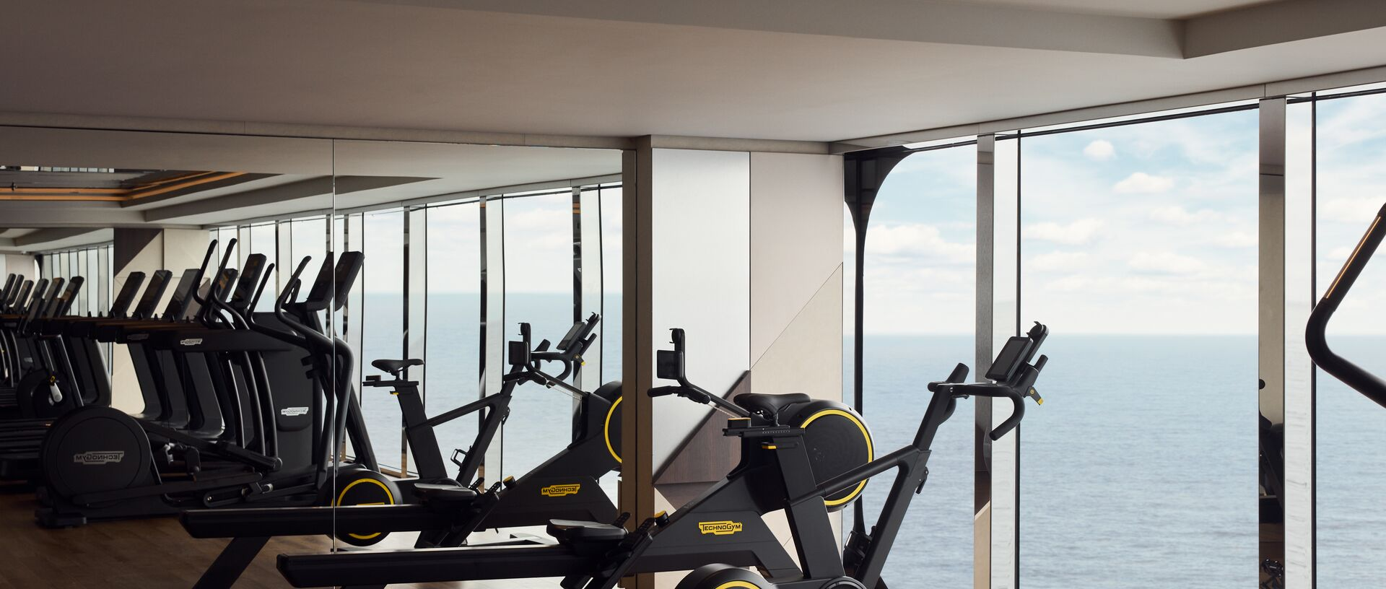

Ideal Traveler Profile
Explora tends to appeal to travelers who:
• Prefer modern design over traditional décor
• Value spacious, contemporary suites
• Appreciate longer, immersive port stays
• Seek a wellness-oriented travel environment
• Enjoy European hospitality style
It resonates strongly with design-conscious travelers and those who prefer subtle luxury over formality.

When Explora May Not Be the Best Fit
Explora may feel less aligned for travelers who:
• Prefer traditional, classical luxury aesthetics
• Seek heavy enrichment programming
• Desire extensive expedition capability
• Want the most comprehensive inclusion structure available
Its strength lies in design, pacing, and atmosphere rather than historical legacy.

Price Positioning
Explora competes firmly in the Ultra-Luxury tier.
Pricing reflects:
• All-suite accommodations
• Modern ship design
• Elevated culinary programming
• Slower, immersive itineraries
For travelers seeking a fresh interpretation of luxury cruising — one grounded in contemporary European sensibility — Explora offers a distinctive alternative within the category.

Scenic Luxury Cruises & Tours
Ultra-Luxury Meets Expedition Innovation
Scenic Luxury Cruises & Tours
Scenic occupies a distinctive space within the Ultra-Luxury landscape — blending refined service with advanced expedition capability.
While Scenic is known in river cruising circles, its Scenic Eclipse ocean vessels redefine the brand’s position within the Ultra-Luxury category.
The concept is straightforward:
Luxury without limits — even in the world’s most remote destinations.
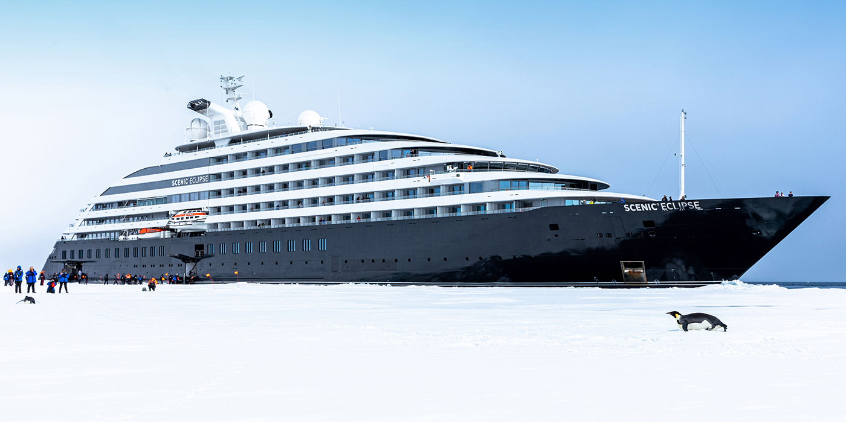

Brand Identity
Scenic Eclipse is often described as a “discovery yacht.”
Its design combines:
• Sleek, contemporary interiors
• All-veranda suite accommodations
• Spacious public areas
• A modern, understated aesthetic
The atmosphere feels sophisticated yet adventure-ready — designed to transition seamlessly between polar exploration and Mediterranean elegance.

What Sets Scenic Apart
1. Expedition Capability with Luxury Standards
Scenic Eclipse vessels are equipped with:
• Purpose-built expedition features
• Advanced navigation systems
• Expert expedition teams
• Zodiac operations in remote regions
The ships are engineered for destinations such as:
• Antarctica
• The Arctic
• Remote South Pacific islands
• The Kimberley coast of Australia
What differentiates Scenic is the combination of technical expedition capability and full Ultra-Luxury accommodation.

2. Helicopters & Submersible
One of Scenic’s most talked-about features is its onboard exploration equipment.
Depending on the sailing and regulatory approvals, Scenic Eclipse has included:
• Helicopters for aerial exploration
• A custom-built submersible for underwater viewing
These experiences extend the concept of destination immersion beyond shore excursions.
While not every guest chooses to participate, the capability reflects Scenic’s ambition to redefine what is possible in luxury exploration.

3. Highly Inclusive Model
Scenic emphasizes a strong inclusion philosophy.
Depending on itinerary, this may include:
• Beverages
• Specialty dining
• Gratuities
• Shore excursions
• Butler service for all suites
The goal mirrors that of other Ultra-Luxury brands: eliminate financial friction during the journey.

4. Dining & Comfort in Remote Regions
Even on expedition itineraries, Scenic maintains elevated culinary standards.
Multiple dining venues allow variety, and suite accommodations are spacious and well-appointed.
The experience balances:
Adventure by day
Refinement by evening
Guests return from Zodiac excursions to Champagne, attentive service, and thoughtfully prepared meals.

Ideal Traveler Profile
Scenic often appeals to travelers who:
• Want expedition-level destinations
• Prefer not to sacrifice luxury for adventure
• Value innovative technology
• Seek remote access without compromise
• Appreciate modern ship design
It is particularly compelling for bucket-list destinations where comfort and safety are equally important.

When Scenic May Not Be the Best Fit
Scenic may feel less aligned for travelers who:
• Prefer strictly traditional luxury environments
• Have no interest in expedition-style itineraries
• Seek highly formal onboard atmosphere
Its strength lies in combining exploration and refinement — not in classical cruise tradition.

Price Positioning
Scenic competes at the upper end of the Ultra-Luxury expedition segment.
Pricing reflects:
• Advanced expedition infrastructure
• All-suite accommodations
• Inclusion model
• Unique exploration capabilities
For travelers who wish to experience remote regions without sacrificing comfort, Scenic presents a distinctive offering within the Ultra-Luxury category.

The Ritz-Carlton Yacht Collection
Hotel Heritage Translated to Sea
The Ritz-Carlton Yacht Collection
The Ritz-Carlton Yacht Collection represents a distinctive evolution within Ultra-Luxury cruising — the translation of a globally recognized hotel brand into an intimate yachting experience.
Rather than positioning itself as a traditional cruise line, Ritz-Carlton approaches the sea as an extension of its hospitality philosophy.
The result feels less like cruising — and more like a private resort that moves.
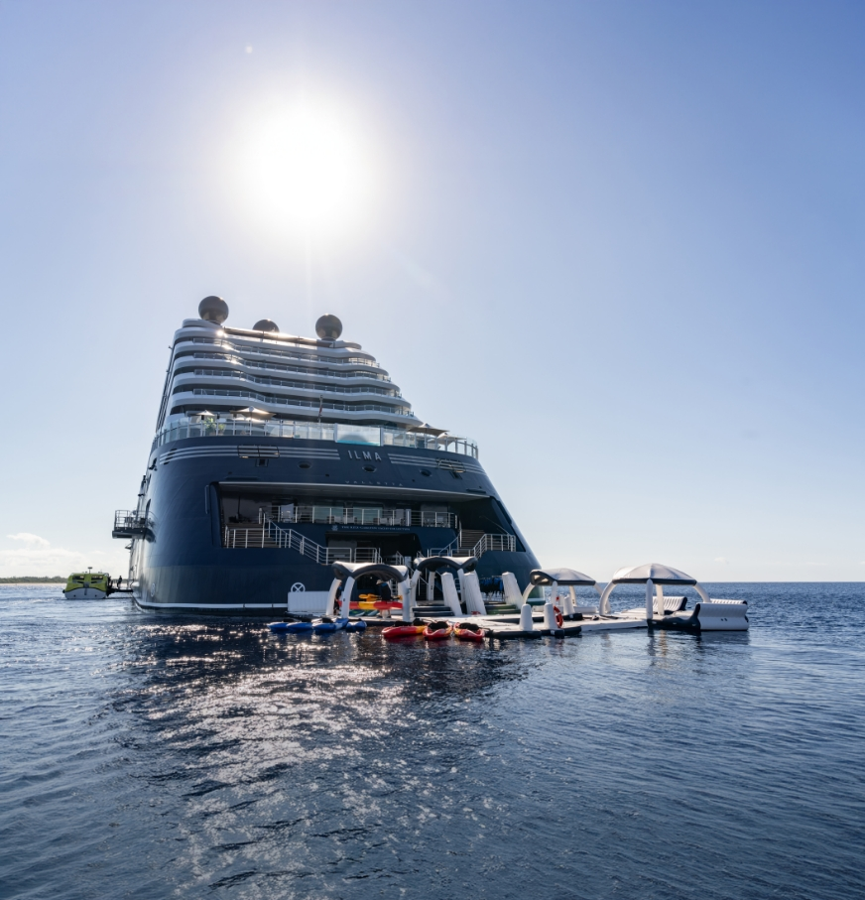

Brand Identity
Ritz-Carlton’s identity is rooted in service legacy.
The yacht collection reflects:
• Contemporary residential design
• Suite-focused accommodations
• Open-air marina platforms
• Relaxed but refined ambiance
The atmosphere leans toward boutique resort rather than formal cruise environment.
Spaces feel modern, airy, and intentionally understated.

What Sets Ritz-Carlton Apart
1. Yacht-Scale Intimacy
Ritz-Carlton’s vessels are smaller than many traditional Ultra-Luxury ships.
Fewer guests create:
• A more social, intimate atmosphere
• Easier movement throughout the ship
• Access to smaller marinas and ports
The experience feels curated rather than orchestrated.

2. Marina Platform Lifestyle
One of the most distinctive features is the marina platform.
When conditions allow, the yacht opens directly to the sea for:
• Water sports
• Swimming
• Direct ocean access
This reinforces the feeling of being on a private yacht rather than on a conventional cruise ship.

3. Culinary Emphasis
Dining reflects Ritz-Carlton’s hospitality roots.
Menus are refined and globally inspired, often developed in collaboration with accomplished culinary professionals.
The approach is elegant yet approachable — focusing on quality ingredients, thoughtful presentation, and relaxed sophistication.
The beverage program aligns naturally with guests accustomed to luxury hotel standards.

4. Service Culture
The Ritz-Carlton brand is known for its “Ladies and Gentlemen serving Ladies and Gentlemen” service philosophy.
That ethos carries into the yacht collection.
Service is attentive, discreet, and polished — drawing on decades of hospitality training across the brand’s global portfolio.
For travelers already familiar with Ritz-Carlton properties, the service style feels comfortably recognizable.

Ideal Traveler Profile
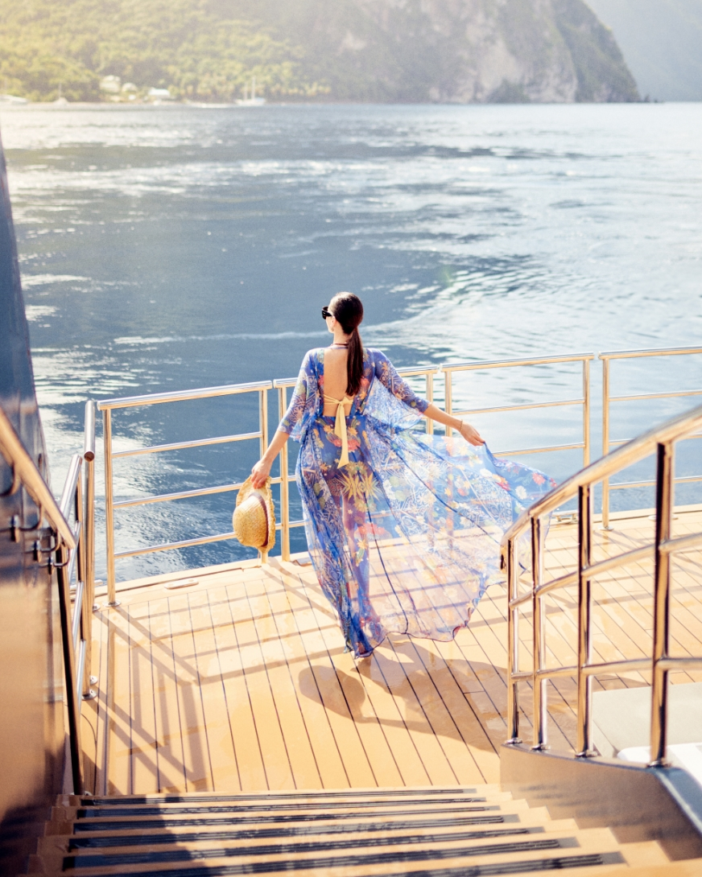

The Ritz-Carlton Yacht Collection tends to attract travelers who:
• Are loyal to the Ritz-Carlton hotel brand
• Prefer boutique yacht scale
• Value relaxed luxury over formal tradition
• Enjoy marina-style lifestyle experiences
• Seek destination immersion with resort-level comfort
It appeals strongly to travelers transitioning from high-end resort vacations to maritime experiences.

When Ritz-Carlton May Not Be the Best Fit
Ritz-Carlton may feel less aligned for travelers who:
• Want unlimited shore excursions included
• Prefer highly structured enrichment programming
• Seek expedition-focused itineraries
• Desire the most comprehensive inclusion model available
Its strength lies in lifestyle and brand heritage rather than comprehensive inclusion or expedition capability.

Price Positioning
Ritz-Carlton competes in the Ultra-Luxury yacht tier.
Pricing reflects:
• Yacht-scale intimacy
• Brand-level service standards
• Elevated culinary programming
• Distinctive marina access
For travelers who value recognizable luxury translated into a more intimate maritime setting, Ritz-Carlton offers a compelling and differentiated experience.

Cruise Line | Ship Scale | Inclusion Level | Butler Service | Expedition Capability | Design Style | Ideal For
Regent Seven Seas Cruises | Small–Mid (All-Suite) | Very High (Air + Unlimited Excursions on many sailings) | Yes (Most Categories) | Limited | Classic, Elegant | Travelers wanting maximum inclusion & seamless simplicity
Crystal Cruises | Mid-Size Luxury | High | Select Categories | Limited | Traditional, Refined | Enrichment-focused travelers who value cultural programming
Seabourn | Small Yacht-Scale | High | Select Categories | Yes (Expedition Ships) | Understated, Relaxed | Travelers seeking intimate, yacht-style luxury
Explora Journeys | Small–Mid All-Suite | High | Yes (Select Levels) | Limited | Modern European | Design-conscious travelers wanting slow, immersive pacing
Scenic Luxury Cruises & Tours | Small Expedition Yacht | Very High | Yes (All Suites) | Strong (Polar & Remote Regions) | Contemporary, Adventure-Ready | Luxury travelers wanting remote destinations without sacrificing comfort
The Ritz-Carlton Yacht Collection | Boutique Yacht | Moderate–High | Yes (All Suites) | Limited | Resort-Like, Contemporary | Hotel-loyal luxury travelers seeking lifestyle yachting

How to Choose the Right Ultra-Luxury Cruise
Matching the Experience to Your Travel Style
In Ultra-Luxury cruising, there is no single “best” cruise line.
There is only the best fit.
Each brand within this category delivers exceptional quality — but they do so with different philosophies, atmospheres, and priorities.
Understanding your own travel style is the key to choosing well.
Below are the most important factors to consider.

1. How Important Is Full Inclusion?
Some travelers want every detail covered upfront.
They prefer:
• Airfare included
• Unlimited shore excursions
• All specialty dining included
• Gratuities included
• No onboard charges
For these guests, a line with a comprehensive inclusion model may feel most comfortable.
Others are comfortable selecting optional experiences à la carte, focusing instead on atmosphere or design.
Clarifying your preference here simplifies the decision immediately.

2. Do You Prefer Yacht Intimacy or Larger Luxury Ships?
Ultra-Luxury ships vary in scale.
Smaller yacht-style vessels offer:
• Greater intimacy
• A social, private-club atmosphere
• Access to smaller ports
Slightly larger Ultra-Luxury ships may offer:
• More dining venues
• Expanded wellness facilities
• Broader onboard programming
Neither is better — but the onboard rhythm differs.

3. Is Expedition or Remote Travel Important?
Some travelers are drawn to:
• Antarctica
• The Arctic
• Remote Pacific islands
• The Kimberley coast
If bucket-list destinations and exploration matter, choosing a line with strong expedition capability becomes essential.
If your focus is the Mediterranean, Northern Europe, or classic cultural itineraries, expedition infrastructure may be unnecessary.

4. Do You Prefer Traditional Elegance or Contemporary Design?
Design philosophy shapes the onboard mood.
Some brands lean toward:
• Classical décor
• Formal evenings
• Traditional luxury cues
Others emphasize:
• Minimalist modern interiors
• Open-air relaxation
• A residential feel
Think of it as choosing between a grand European hotel and a sleek boutique property.
Both are luxurious — but the energy differs.

5. How Important Is Culinary Identity?
If food and wine are central to your travel enjoyment, consider:
• Chef collaborations
• Destination-driven menus
• Wine program depth
• Culinary enrichment opportunities
Some Ultra-Luxury lines emphasize traditional fine dining, while others adopt a more contemporary, regional approach.

6. What Atmosphere Feels Most Comfortable?
Ask yourself:
Do you prefer structured enrichment and guest lecturers?
Or a more relaxed, open social environment?
Do you enjoy formal evenings?
Or a resort-like atmosphere?
Ultra-Luxury does not mean identical.
Each brand attracts a slightly different traveler profile.

7. What Does Value Mean to You?
Ultra-Luxury pricing reflects inclusion, staffing, space, and service.
However, value perception varies.
For some travelers, maximum inclusion offers clarity and peace of mind.
For others, atmosphere and destination access matter more than bundled airfare.
Understanding what you personally value most helps narrow choices quickly.

The Right Choice Is Personal
The goal of Ultra-Luxury travel is not extravagance.
It is ease.
When the ship’s personality aligns with your travel style, the experience feels effortless.
When it does not, even a beautiful ship may feel slightly misaligned.
Selecting the right cruise line is less about ranking and more about resonance.
And resonance begins with clarity.

Closing Reflections
Luxury, Defined by Ease
Ultra-Luxury cruising is often described in terms of suites, cuisine, and service.
Those elements matter.
But what distinguishes this category most clearly is not extravagance.
It is effortless.
When a journey is thoughtfully designed — when space feels generous, service feels intuitive, and inclusions eliminate friction — travel changes.
You are no longer managing logistics.
You are present.
You wake without hurry.
You explore without calculation.
You dine without interruption.
You return to a suite that feels like a retreat rather than a cabin.
In the Ultra-Luxury category, refinement replaces excess.
Clarity replaces complication.
Ease replaces urgency.
The cruise lines profiled in this guide deliver that experience in their own way.
Some emphasize comprehensive inclusion.
Some prioritize yacht-style intimacy.
Some blend expedition capability with luxury comfort.
Others translate renowned hotel heritage into a maritime setting.
There is no universal “best.”
There is only alignment.
The right ship for you depends on how you travel — what you value, what atmosphere feels natural, and how you prefer to explore the world.
For some, that means traditional elegance and enrichment.
For others, it means contemporary design and slower itineraries.
For others still, it means remote destinations without sacrificing comfort.
The common thread is simplicity elevated.
Travel at this level is not about showing the world where you’ve been.
It is about how it felt while you were there.
If this guide has clarified your thinking, then it has served its purpose.
And if your next journey includes the sea, may it be chosen not by prestige alone — but by fit.
Because in Ultra-Luxury travel, the experience should feel as though it was designed specifically for you.
Bruce M. Schutte, CTA
Luxury Cruise & Wine Travel Specialist
Founder, Capon River Cruise Company
Begin the Conversation
Ultra-Luxury cruising is not a one-size-fits-all decision.
The right choice depends on:
• Your preferred atmosphere
• Your destination priorities
• Your desired level of inclusion
• Your pace of travel
• Your expectations of service
While brochures highlight amenities, the true difference lies in alignment.
Selecting the right Ultra-Luxury cruise line is less about ranking — and more about resonance.
If you are considering a voyage within the next 12–24 months, I would be happy to help you evaluate the options personally.
Our conversation might include:
• Comparing specific ships and itineraries
• Clarifying inclusion structures
• Identifying the best suite category
• Evaluating value across brands
• Exploring pre- and post-cruise extensions
There is no obligation — only clarity.
Luxury travel should feel effortless from the very beginning.
If you would like a private consultation, you may:
• Email: bruce@caponrivercruisecompany.com
• Call (540) 454-0495
I look forward to helping you design a journey that feels distinctly your own.
Bruce M. Schutte, CTA
Luxury Cruise & Wine Travel Specialist
Founder, Capon River Cruise Company

